**VIDEO GAME SALES ANALYSIS**

An SQL project analyzing video game sales data to uncover key insights into sales trends, console preferences, and regional popularity using python for visualizations.

**TABLE OF CONTENTS**

Introduction

Objectives

Dataset Description

Data Cleaning and Processing

Data Analysis

Data Visualization

Recommendation

Conclusion

**INTRODUCTION**

The video game industry has grown significantly over the years, with multiple platforms (consoles) and genres catering to different audiences worldwide. Understanding sales trends can help developers, publishers, and marketers make informed decisions about game development and distribution. This project analyzes video game sales data to uncover key insights into sales trends, console preferences, and regional popularity using two programming language SQL and Python.

### ****OBJECTIVES****

The main goals of this analysis are:

1. Identify the **best-selling games worldwide**.
2. Determine which **year had the highest sales** and analyze the industry's growth over time.
3. Explore whether **certain consoles specialize in specific genres**.
4. Identify **titles that performed well in one region but flopped in another**.
5. Provide recommendations based on the findings.

### ****DATASET DESCRITION****

The dataset for this project is sourced from Maven Analytics website designed specifically for practice purposes. It is presented in an Excel file with one table having 14 columns and 64,016 rows.

The dataset contains the following columns:

* img – Image link for the game
* title – Name of the game
* console – The platform it was released on (e.g., PS4, Xbox, Switch)
* genre – The game’s genre (e.g., Action, RPG, Sports)
* publisher – The company that published the game
* developer – The studio that developed the game
* critic_score – Review score given by critics
* total_sales – Total worldwide sales (in millions)
* na_sales, jp_sales, pal_sales, other_sales – Regional sales breakdown
* release_date – The date the game was released
* last_update – The most recent update in the dataset

### ****DATA CLEANING AND PREPROCESSING****

* Handle missing values (e.g., missing critic_score or release_date).
* Convert release_date to a proper DATE format.
* Standardize genre names to avoid inconsistencies (e.g., "Action" vs. "Action Game").

**DATA ANALYSIS USING SQL**

1. **Which Titles Sold the Most Worldwide?**

Select Top 1 Title,

Round(Sum (total_sales), 0) As Total_Sales

From vgchartz_2024

Group by Title

Order by Sum (total_sales) DESC

This query identifies the highest-selling games of all time.

1. **Which Year Had the Highest Sales? Has the Industry Grown?**

Select Top 1 release_date As release_year,

Round(Sum (total_sales), 0) As Total_Sales

From vgchartz_2024

Group by release_date

Order by Sum (total_sales) DESC

This query finds the **peak year** for video game sales.

The query below sort’s release_year chronologically to help visualize the **growth trends of the industry**.

SELECT release_date AS release_year,

Round(Sum(total_sales), 0) AS total_sales

FROM vgchartz_2024

WHERE release_date IS NOT NULL

GROUP BY release_date

ORDER BY release_year ASC;

### *****Insight Gained******:*

* Allows visualization of the industry growth or decline.
* A steady increase suggests industry expansion, while a decline could indicate market saturation or changing trends.

***How to Interpret the Results?***

* If **total sales increase over time**, the industry is **growing**.
* If there are **ups and downs**, it might indicate market fluctuations.
* A **decline in later years** might suggest market saturation or shifts in consumer behavior.

1. **Do Consoles Specialize in a Particular Genre?**

***Find the Number of Games per Console and Genre***

SELECT console, genre, COUNT(*) AS game_count

FROM vgchartz_2024

GROUP BY console, genre

ORDER BY console, game_count DESC;

### *****Insight Gained******:*

* This query shows how many games exist for each genre per console.
* Helps identify if a console has a strong focus on a specific genre.

### *****Find the Most Common Genre Per Console*****

WITH GenreRank AS (

SELECT console, genre, COUNT(*) AS game_count,

RANK() OVER (PARTITION BY console ORDER BY COUNT(*) DESC) AS rank

FROM vgchartz_2024

GROUP BY console, genre

)

SELECT console, genre, game_count

FROM GenreRank

### WHERE rank = 1;

***Explanation:***

* CTE (WITH GenreRank AS **(...))**: Creates a temporary table (GenreRank) that ranks genres per console.
* RANK() OVER (PARTITION BY console ORDER BY COUNT(*) DESC) AS rank: Assigns a ranking to each genre per console, based on the number of games.
* WHERE rank = 1: Filters results to return only the top-ranked genre per console.

***Insight Gained:***

* Directly shows the most dominant genre for each console.
* Helps in understanding which types of games are most associated with a specific console.

1. **What Titles Were Popular in One Region but Flopped Elsewhere?**

SELECT title,

na_sales, jp_sales, pal_sales, other_sales,

(na_sales - (jp_sales + pal_sales + other_sales)) AS na_bias,

(jp_sales - (na_sales + pal_sales + other_sales)) AS jp_bias,

(pal_sales - (na_sales + jp_sales + other_sales)) AS pal_bias

FROM vgchartz_2024

ORDER BY na_bias DESC, jp_bias DESC, pal_bias DESC

### *****Explanation******:*

* SELECT title, na_sales, jp_sales, pal_sales, other_sales: Retrieves sales data per region.
* na_sales - (jp_sales + pal_sales + other_sales) AS na_bias:
  + If this value is high, the game is **highly successful in North America but flopped elsewhere**.
* jp_sales - (na_sales + pal_sales + other_sales) AS jp_bias:
  + A high value here indicates **Japanese success but poor sales elsewhere**.
* pal_sales - (na_sales + jp_sales + other_sales) AS pal_bias:
  + A high value shows **strong sales in PAL regions but low sales elsewhere**.
* ORDER BY na_bias DESC, jp_bias DESC, pal_bias DESC:
  + Sorts the results to find games with the highest regional biases.

### *****Insight Gained******:*

* Identifies games with **regional popularity trends**.
* Helps understand cultural differences in gaming preferences.
  + Example: **JRPGs (Japanese Role-Playing Games) often sell well in Japan but underperform in North America**.
  + **Sports games may be strong in North America and Europe but weak in Japan**.

### ****Findings & Insights****

* **Best-Selling Games**: The top games are usually from well-known franchises like Grand Theft Auto, Call of Duty, and Pokémon.
* **Industry Growth**: The gaming industry saw a **major increase in sales around the mid-2000s**, potentially due to the rise of online multiplayer gaming and digital sales.
* **Console-Genre Trends**:
  + **PlayStation & Xbox**: Dominated by Action and Shooter games.
  + **Nintendo Consoles**: Have a strong presence in Platformers and Family-friendly games.
  + **Handheld Consoles**: Tend to have more RPG(Role-playing Game) and Adventure games.
* **Regional Popularity Differences**:
  + **JRPGs** tend to sell well in Japan but underperform in North America.
  + **Sports games** are popular in North America and Europe but struggle in Japan.
  + **First-person shooters** perform best in North America.

**DATA VISUALIZATION**

Using Python (Matplotlib & Seaborn) to make the insights more engaging. Below are some visualization ideas along with the relevant Python code.

## ****1. Most Sold Video Games Worldwide (Bar Chart)****

**Insight:** Displays the top 10 best-selling games globally.

### ****Code:****

import pandas as pd

import matplotlib.pyplot as plt

import seaborn as sns

**# Load dataset**

df = pd.read_csv("vgchartz-2024.csv")

**# Select top 10 best-selling games**

top_games = df.nlargest(10, "total_sales")

**# Plot**

plt.figure(figsize=(12, 6))

sns.barplot(x="total_sales", y="title", data=top_games, palette="viridis")

plt.xlabel("Total Sales (Millions)")

plt.ylabel("Game Title")

plt.title("Top 10 Best-Selling Video Games Worldwide")

plt.show()

### ****Expected Output:****

A **horizontal bar chart** showing the **top-selling games and their total sales**.

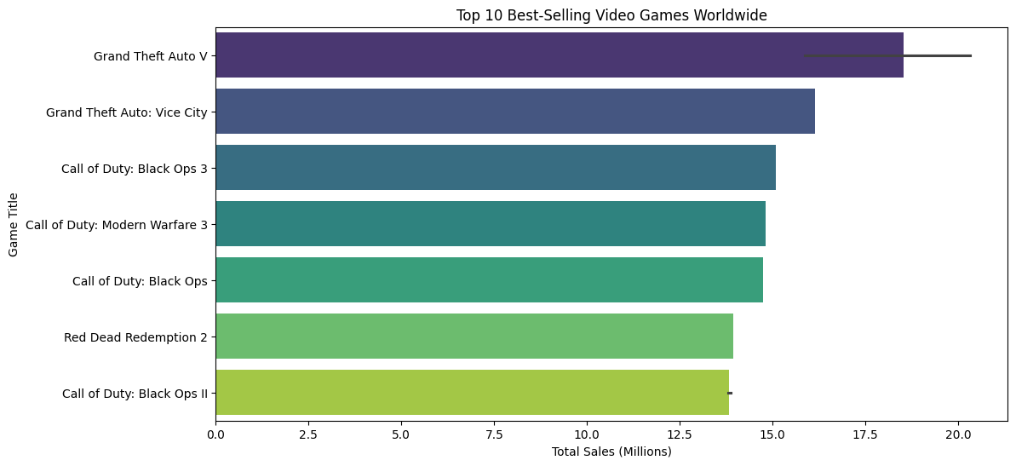

## ****2. Yearly Sales Trend (Line Chart)****

**Insight:** Shows whether the gaming industry is growing over time.

### ****Code:****

**# Convert release_date to datetime format**

df["release_date"] = pd.to_datetime(df["release_date"], errors='coerce')

**# Extract year and sum sales per year**

yearly_sales = df.groupby(df["release_date"].dt.year)["total_sales"].sum().reset_index()

**# Plot**

plt.figure(figsize=(12, 6))

sns.lineplot(x="release_date", y="total_sales", data=yearly_sales, marker="o", color="b")

plt.xlabel("Year")

plt.ylabel("Total Sales (Millions)")

plt.title("Yearly Video Game Sales Trend")

plt.grid(True)

plt.show()

### ****Expected Output:****

A **line graph** showing the **rise and fall of total sales per year**, indicating industry growth.

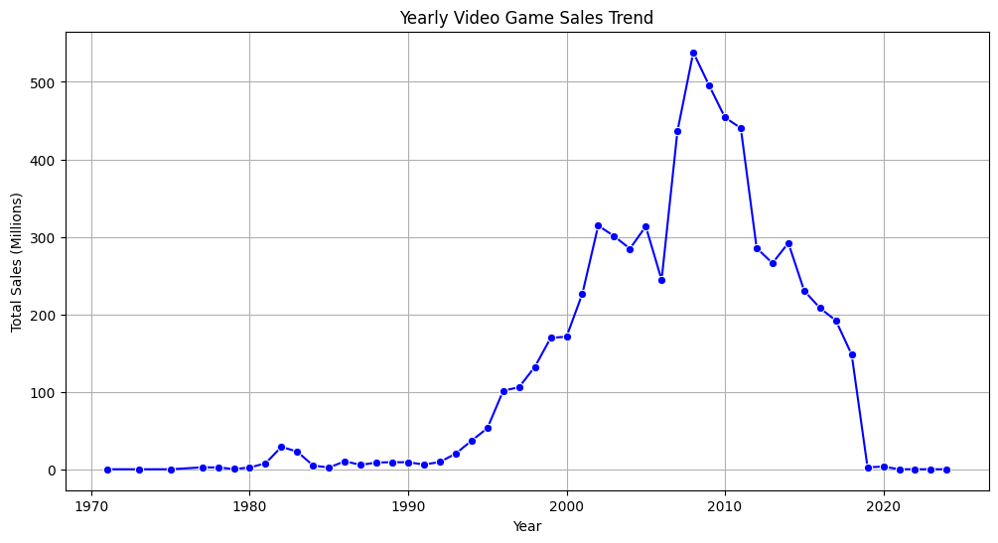

## ****3. Console Specialization in Genres (Heatmap)****

**Insight:** Identifies which consoles dominate specific genres.

### ****Code:****

**# Create a pivot table of console vs genre counts**

console_genre_pivot = df.pivot_table(index="console", columns="genre", aggfunc="size", fill_value=0)

**# Plot**

plt.figure(figsize=(15, 6))

sns.heatmap(console_genre_pivot, cmap="coolwarm", linewidths=0.5, annot=True, fmt="d")

plt.xlabel("Genre")

plt.ylabel("Console")

plt.title("Console Specialization in Game Genres")

plt.show()

### ****Expected Output:****

A **heatmap** where **dark red colors indicate high game counts** for a particular **console-genre combination**.

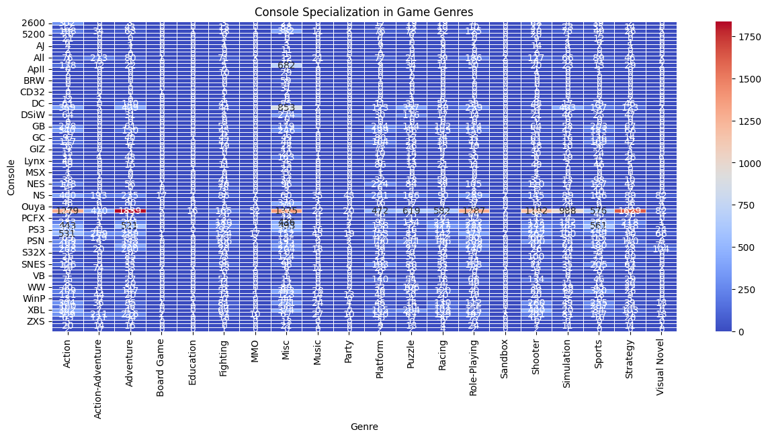

## ****4. Regional Sales Comparison (Stacked Bar Chart)****

**Insight:** Shows sales distributions across different regions for top games.

### ****Code:****

**# Select top-selling games**

top_games = df.nlargest(10, "total_sales")

**# Plot**

top_games.plot(

x="title",

y=["na_sales", "jp_sales", "pal_sales", "other_sales"],

kind="bar",

stacked=True,

figsize=(12, 6),

colormap="tab10"

)

plt.xlabel("Game Title")

plt.ylabel("Total Sales (Millions)")

plt.title("Regional Sales Distribution of Top 10 Games")

plt.legend(["NA Sales", "JP Sales", "PAL Sales", "Other Sales"])

plt.xticks(rotation=45)

plt.show()

### ****Expected Output:****

A **stacked bar chart** showing **how different regions contribute to total sales** for top-selling games.

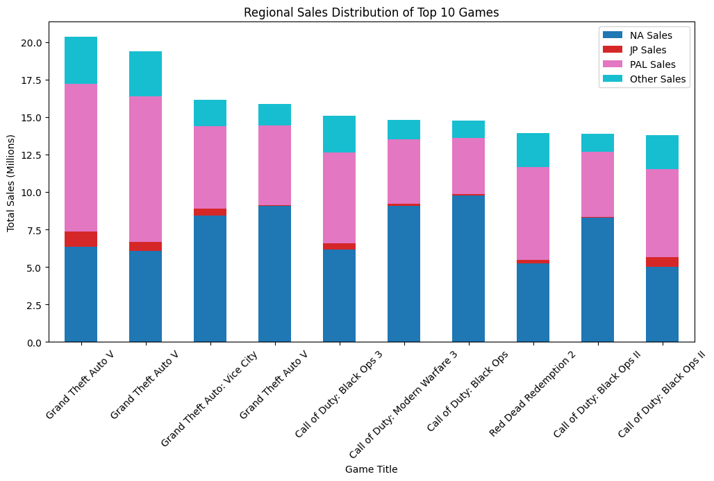

## ****5. Popularity in One Region vs. Another (Scatter Plot)****

**Insight:** Identifies games that are **hits in one region but flops in another**.

### ****Code:****

**# Plot sales in NA vs Japan**

plt.figure(figsize=(8, 6))

sns.scatterplot(x=df["na_sales"], y=df["jp_sales"], alpha=0.6)

plt.xlabel("North America Sales (Millions)")

plt.ylabel("Japan Sales (Millions)")

plt.title("Regional Popularity: NA vs. Japan")

plt.axhline(y=df["jp_sales"].mean(), color="r", linestyle="--", label="JP Avg Sales")

plt.axvline(x=df["na_sales"].mean(), color="b", linestyle="--", label="NA Avg Sales")

plt.legend()

plt.show()

### ****Expected Output:****

A **scatter plot** showing **games that are popular in North America but not in Japan**, and vice versa.

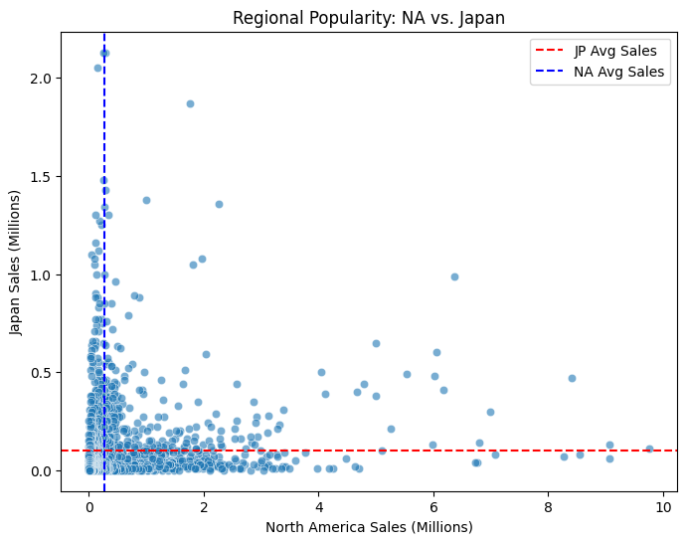

### ****RECOMMENDATIONS****

* **Game Developers**: Target specific consoles based on genre success.
* **Publishers**: Market region-specific games effectively (e.g., JRPGs in Japan).
* **Retailers**: Stock games based on **regional preferences** to maximize sales.

### ****CONCLUSION****

**Sales trends** show that certain games and genres are more successful in specific regions than others and the **gaming industry has grown over time**, with spikes in certain years. Some **consoles are better suited for specific game genres**.

*Thank you for reading*